Mr. Busby Salsa

1 large canned 32 oz. peeled tomatoes
1 jalapeno
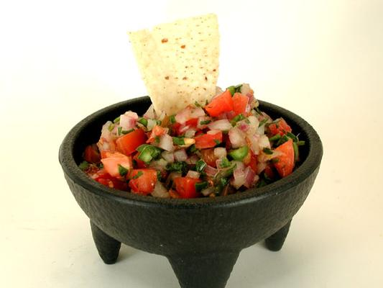
1/2 Walla Walla sweet onion
2 garlic cloves
½ bunch green onions
1 tsp. sea salt
pinch of pepper
½ bunch cilantro
Juice of 1/2 lime

